Parent Signature _________________________

Name__________________ Date_________________

**Study Guide: Northeast Region**

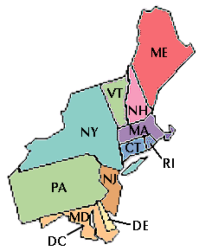

**What to Study:**

* Study the questions you answered on your organizer during our S.S. train tour
* The notes below
* Be able to read a map population density map.

**Resources**

* Social Studies Ch. 4 Northeast train ride organizer
* Social Studies textbook and TCI online: The website is a great resource to help you study! On it you will find textbook pages, notecards, and a practice quiz!

**Northeast Region**

**West Quoddy Head, Maine:** the northeast has mountains and harbors

**Plymouth, Massachusetts:** in a democracy leaders are chosen by the people

**Boston, Massachusetts:** the American Revolution (the war we fought against Great Britain) gave our nation its freedom

**Erie Canal:** boats can travel from Lake Erie to New York City

**New York City:** known as the city of skyscrapers

**Hershey, Pennsylvania:** mass production is making large quantities of the same product (Hershey chocolate is an example of this)

**Philadelphia, Pennsylvania:** the constitution protects our right to say what we think

**Washington D.C.:** congress makes laws

**Population Density**: a measure of the number of people living in one area

**Megalopolis**: string of towns and cities that is densely populated